

**Comsats University Islamabad**

**Abbottabad Campus**

**Real Time Embedded System**

**Lab Task # 2**

**Submitted by,**

|  |  |
| --- | --- |
| Aazan Ali Khan | FA20-EEE-026 |

**Submitted to,**

Dr. Syed Mashood Murtaza

**Department of Electrical &**

**Computer Engineering**

**Task 2:**

**Setting up Multitasking applications in Energia MT**

Here is the link: <https://energia.nu/download/>. You can download this software based on your operating system.

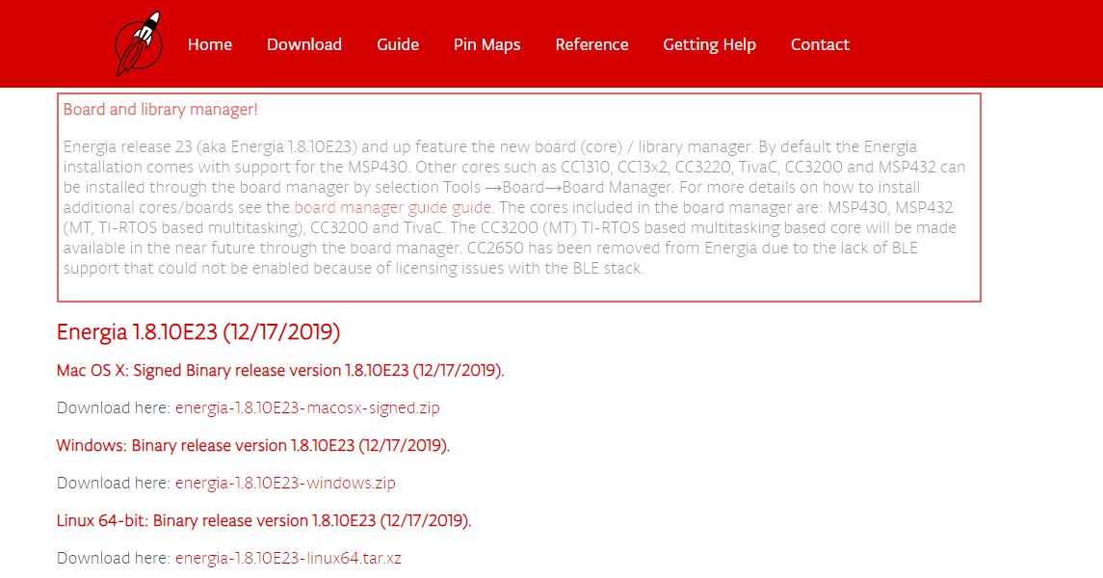

After installing extract the file.

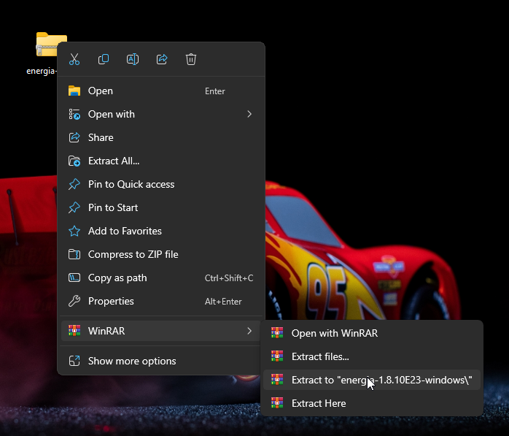

After extracting open the folder and double click on energia.exe.

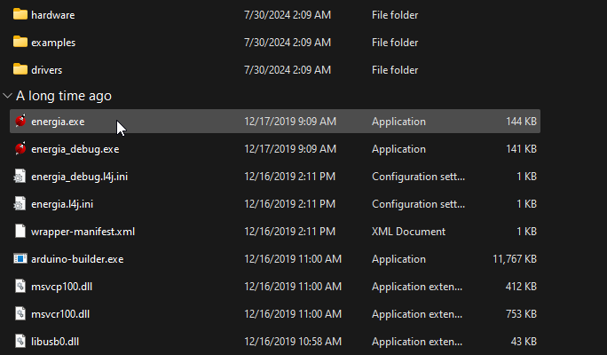

After the software opens click on File → Examples → MultiTasking → MultiBlink

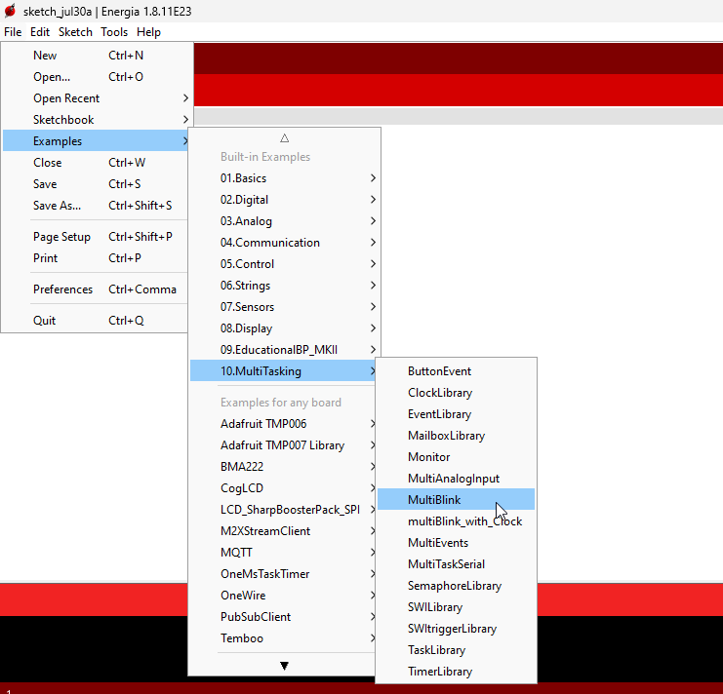

The new window will pop up which contains four tabs as shown

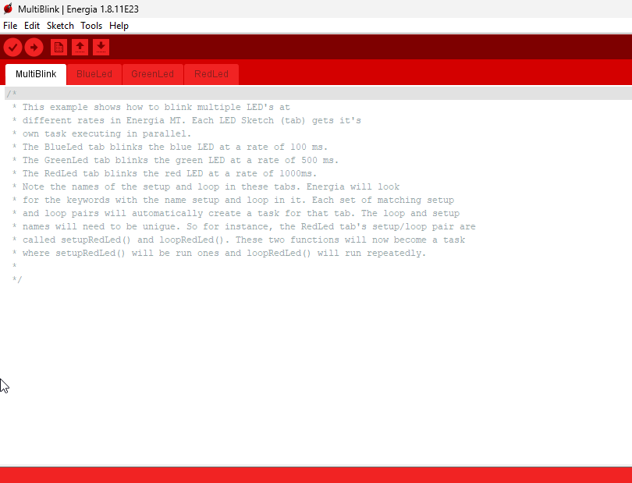

Now you can perform multitasking,

Tab1

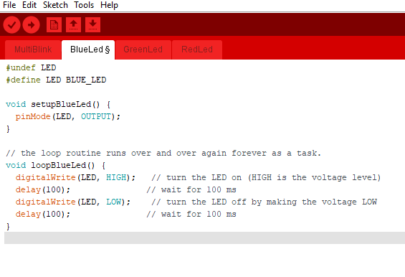

Tab2

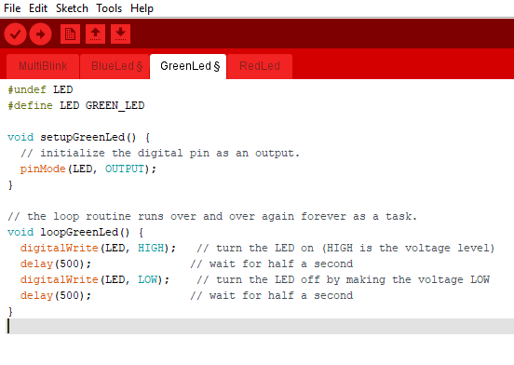

Tab3

